**PGDAC 0323 – PROJECT DOCUMENT SUBMISSION- PART III**

|  |  |  |  |
| --- | --- | --- | --- |
| Doc. Name | **SOFTWARE REQUIREMENT SPECIFICATION –Version-3** | | |
| Project Title | HelloMaid | | |
| Doc. No. | 230360920003 | Group | 01 |

|  |  |  |  |
| --- | --- | --- | --- |
| Functional  designation of approving authority | **Project Guide Name:** Suraja PK | Functional  designation of issuing authority | **Project Leader Name:** Aditya  Wath |
|  | | | |

|  |  |  |  |
| --- | --- | --- | --- |
| **Team Member Details** | | | |
| PRN | Participant Name | Email | Phone |
| 230360920001 | Abhijit Wagh | [abhijitw7058@gmail.com](mailto:abhijitw7058@gmail.com) | 7219554986 |
| 230360920002 | Aditi Pawar | [adac0666@gmail.com](mailto:adac0666@gmail.com) | 9657835855 |
| 230360920003 | Aditya Palkar | [adipalkarofcl@gmail.com](mailto:adipalkarofcl@gmail.com) | 9130812106 |
| 230360920004 | Aditya Wath | [wath.adi@gmail.com](mailto:wath.adi@gmail.com) | 7387279721 |
| 230360920005 | Aditya Deshmukh | [adityadeshmukh011@gmail.com](mailto:adityadeshmukh011@gmail.com) | 7719907801 |

Approved By :

Suraja PK

(Project Guide) Date of approval: _ _ / _ _/ _ _ _

Abstract

The HelloMaid project is dedicated to crafting an efficient and user-friendly Online Maid Booking System. This web application acts as an all-encompassing solution for both users and maids, eradicating the necessity for laborious physical searches, word-of-mouth recommendations, or individualized requests.

For users, it provides a hassle-free avenue to effortlessly locate and book maids via a single online platform. No more tedious phone calls or inquiries. Meanwhile, for maids, it offers a chance to secure work opportunities that align with their skills and availability, all within the realm of the internet. This streamlined process simplifies the job-seeking experience.

The paramount objective of the HelloMaid project is to bestow a seamless and convenient user experience. It aims to connect users with the right maids swiftly and enable maids to access job opportunities with ease. Ultimately, this endeavor aspires to deliver top-notch service provision, enhancing the lives of users and maids alike through the power of digital connectivity. Say goodbye to the hassles of traditional maid hiring; HelloMaid is here to transform the way we find and book domestic help.

**Table of Contents**

**Abstract......................................................................................................................................**

1. Introduction 5
   1. Document Purpose **5**
   2. Project Background **5**
   3. Aim & Objectives **5**
2. Business Requirements Overview 6
3. Functional Requirements 6
   1. Customer Module **6**
   2. Maid Module **6**
   3. Admin Module **7**
4. Non-FunctionalRequirement 7
   1. E-R Diagram 8
   2. Use Case Diagram 9
      1. Admin 9
      2. User 10
      3. Maid 11
      4. Sequence diagram **12**
5. Database Design 13
   1. Maid 13
   2. User 14
   3. Services… **14**
   4. Booking_info **15**
   5. Maid_review 15
6. Snapshots 13
7. Future Scope 29
8. Conclusion 30
9. **References 31**

**List of Figures**

**E-R Diagram 8**

**Use Case Diagrams 9**

Fig 1 Admin 9

Fig 2 Customer 10

Fig 3 Maid 11

# Introduction:

## Document Purpose:

Online Maid Booking System is a system created to provide household help services to the customers

## Project Background:

As we move to new city or place, it’s become quite troublesome to search for maid and then end up with no option...

So keeping in mind the problem we come up to the solution of booking online Maid ... where customer can book maid online by visiting our website.

## Aim & Objectives:

The main objective of this project is building a website which will help maids to get work. Booking software is the backend of a business's online website. It empowers business owners to easily create a website to provide maids easily available by booking them for helping in household works like cleaning, washing, cooking, etc.

Here if suppose some maids want to use this facility and want to learn how it is possible and how they can use e-booking to register, they must have knowledge of computer then they can directly register in the site and get the work.

On the other side, customer can also register and book maid online as per their needs.

# Business Requirements Overview

* Maid booking system is the public web application.
* Maid booking system will be opened to the global, but in the phase 1, the main target is in the India.
* There are mainly two types of user. One is the Customer and other is Maid.
* Customer can search for the maid available for household work.
* Maid booking system provides the functions which connect the customers and the maid efficiently.
* Maid booking system could be maintained by Administrator.

1. **Functional Requirements Overview**

Maid booking system consists of four modules described as below.

1. Customer Module
2. Maid Module
3. Admin Module
4. Message Acknowledgement Module

## Customer Module

* + - Customer can register and create their account.
    - Maid booking system provides the function which allows customer to search and book maid as per their need.
    - Customer is able to browse existing list price of maid.
    - Customer can view the history of their previous booked maid.
    - Customer can update personal details.

## Maid Module

* + - Maid can register and create their account.
    - Maid booking system provides the function which allows maid to get the work.
    - Maid can update personal details.

## Admin Module

* + - Maid booking system should provide all function to admin how to handle the System.
    - What are the customer and maid are using this system and are they authorized.
    - Could able to know all the Transaction.
  1. **Message Acknowledgement Module**
     + Message Acknowledge Module should provide the entire users feedback message about their completion of transaction.
     + Message Acknowledgement will send to both customer and maid for the booking.

**Non-functional Requirements**

* The website should use professional design, look and feel and color scheme.
* Users will have no limitations for accessing the application through Internet. The portal being an internet application, it is difficult specify exact number of visitor or users. Hence we will target the system to support between 5 and 10 million users on launch of phase 1.
* Being a public website, the site must follow general usability guidelines for menus, navigation, colors, links and other actions provided on the screens.
* The system should be designed in such a manner that user will be able to complete tasks in minimum number of steps.

.

* 1. **E-R Diagram**

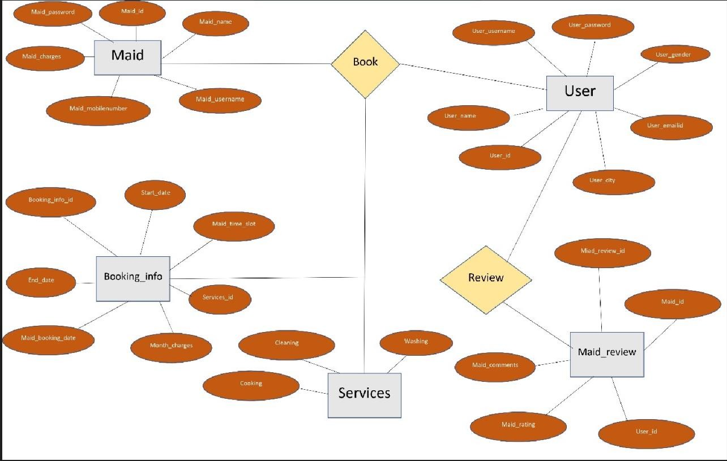

Fig. E-R Diagram

* 1. **Use-Case Diagram**
     1. **Admin:**

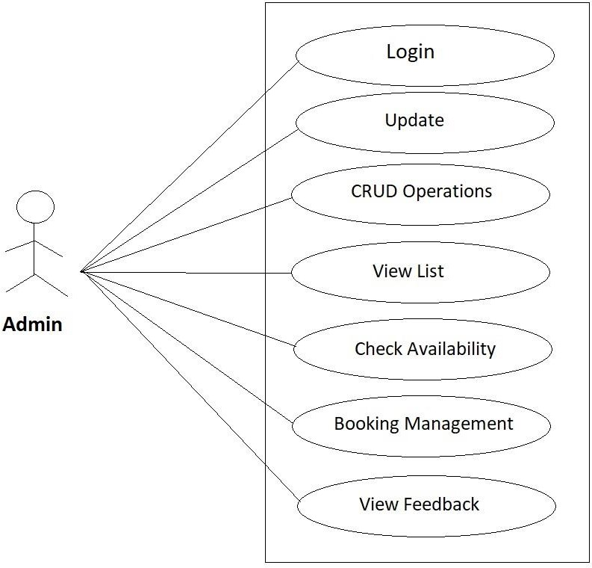

Fig. Use-Case Diagram for Admin

### User :

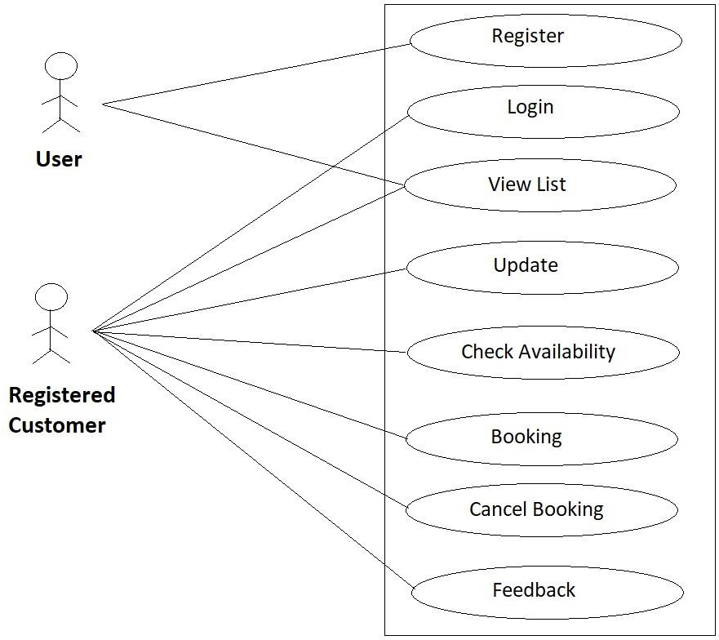

Fig. Use-Case Diagram for User

* + 1. **Maid :**

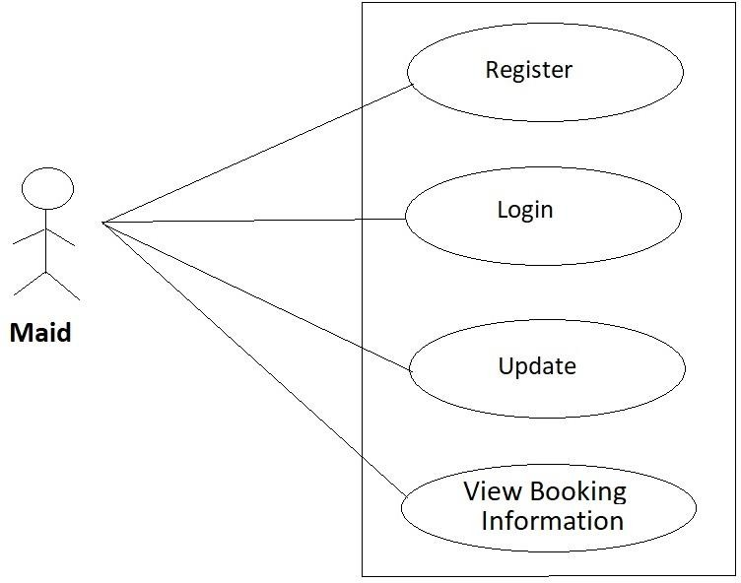

Fig. Use-Case Diagram for Maid

* + 1. **Sequence Diagram :**

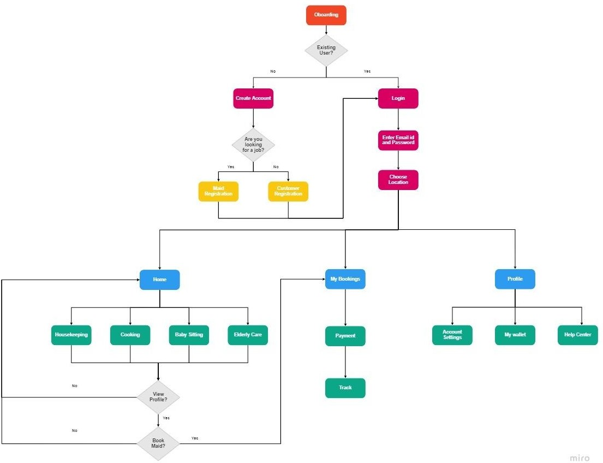

Fig. Sequence Diagram

1. **Database Design:**

**1] Maid**

|  |  |  |  |  |  |
| --- | --- | --- | --- | --- | --- |
| **Field** | **Type** | **Null** | **Key** | **Default** | **Extra** |
| **maid_id** | **Int** | **NO** | **PRI** | **NULL** | **auto_increment** |
| **maid_address** | **varchar(255)** | **YES** |  | **NULL** |  |
| **maid_adhar_card** | **varchar(255)** | **YES** |  | **NULL** |  |
| **maid_age** | **Int** | **YES** |  | **NULL** |  |
| **maid_city** | **varchar(255)** | **YES** |  | **NULL** |  |
| **maid_email_id** | **varchar(255)** | **YES** |  | **NULL** |  |
| **maid_experience** | **Int** | **YES** |  | **NULL** |  |
| **maid_mobile_no** | **varchar(255)** | **YES** |  | **NULL** |  |
| **maid_name** | **varchar(255)** | **YES** |  | **NULL** |  |
| **maid_password** | **varchar(255)** | **YES** |  | **NULL** |  |
| **maid_pincode** | **varchar(255)** | **YES** |  | **NULL** |  |
| **maid_police_ verification_certificate** | **varchar(255)** | **YES** |  | **NULL** |  |
| **maid_username** | **varchar(255)** | **YES** |  | **NULL** |  |
| **month_charges** | **Int** | **YES** |  | **NULL** |  |
| **services_id** | **Int** | **YES** | **MUL** | **NULL** |  |

1. **User**

|  |  |  |  |  |  |  |
| --- | --- | --- | --- | --- | --- | --- |
| **Field** | **Type** | **Null** | **Key** | **Default** | **Extra** |  |
| **user_id** | **Int** | **NO** | **PRI** | **NULL** | **auto_increment** |  |
| **user_address** | **varchar(255)** | **YES** |  | **NULL** |  |  |
| **user_adhar_card** | **varchar(255)** | **YES** |  | **NULL** |  |  |
| **user_city** | **varchar(255)** | **YES** |  | **NULL** |  |  |
| **user_email_id** | **varchar(255)** | **YES** |  | **NULL** |  |  |
| **user_family_members** | **Int** | **YES** |  | **NULL** |  |  |
| **user_gender** | **varchar(255)** | **YES** |  | **NULL** |  |  |
| **user_mobile_no** | **varchar(255)** | **YES** |  | **NULL** |  |  |
| **user_name** | **varchar(255)** | **YES** |  | **NULL** |  |  |
| **user_password** | **varchar(255)** | **YES** |  | **NULL** |  |  |
| **user_pincode** | **varchar(255)** | **YES** |  | **NULL** |  |  |
| **user_rooms** | **Int** | **YES** |  | **NULL** |  |  |
| **user_username** | **varchar(255)** | **YES** |  | **NULL** |  |  |

1. **Services**

|  |  |  |  |  |  |
| --- | --- | --- | --- | --- | --- |
| **Field** | **Type** | **Null** | **Key** | **Default** | **Extra** |
| **services_id** | **Int** | **NO** | **PRI** | **NULL** | **auto_increment** |
| **base_charges** | **Int** | **YES** |  | **NULL** |  |
| **services_name** | **Varchar(255)** | **YES** |  | **NULL** |  |

1. **Booking_Info**

|  |  |  |  |  |  |
| --- | --- | --- | --- | --- | --- |
| **Field** | **Type** | **Null** | **Key** | **Default** | **Extra** |
| **booking_info_id** | **Int** | **NO** | **PRI** | **NULL** | **auto_increment** |
| **end_date** | **Date** | **YES** |  | **NULL** |  |
| **maid_booking_date** | **Date** | **YES** |  | **NULL** |  |
| **maid_time_slots** | **varchar(255)** | **YES** |  | **NULL** |  |
| **month_charges** | **Int** | **YES** |  | **NULL** |  |
| **start_date** | **Date** | **YES** |  | **NULL** |  |
| **services_id** | **Int** | **YES** | **MUL** | **NULL** |  |
| **maid_id** | **Int** | **YES** | **MUL** | **NULL** |  |
| **user_id** | **Int** | **YES** | **MUL** | **NULL** |  |

1. **Maid_review**

|  |  |  |  |  |  |
| --- | --- | --- | --- | --- | --- |
| **Field** | **Type** | **Null** | **Key** | **Default** | **Extra** |
| **maid_review_id** | **Int** | **NO** | **PRI** | **NULL** | **auto_increment** |
| **maid_comments** | **varchar(255)** | **YES** |  | **NULL** |  |
| **maid_rating** | **varchar(255)** | **YES** |  | **NULL** |  |
| **maid_id** | **Int** | **YES** | **MUL** | **NULL** |  |
| **user_id** | **Int** | **YES** | **MUL** | **NULL** |  |

1. **Snapshots:**
   1. **Home Page:**

Following snapshot shows the Home page for Online Maid Booking System

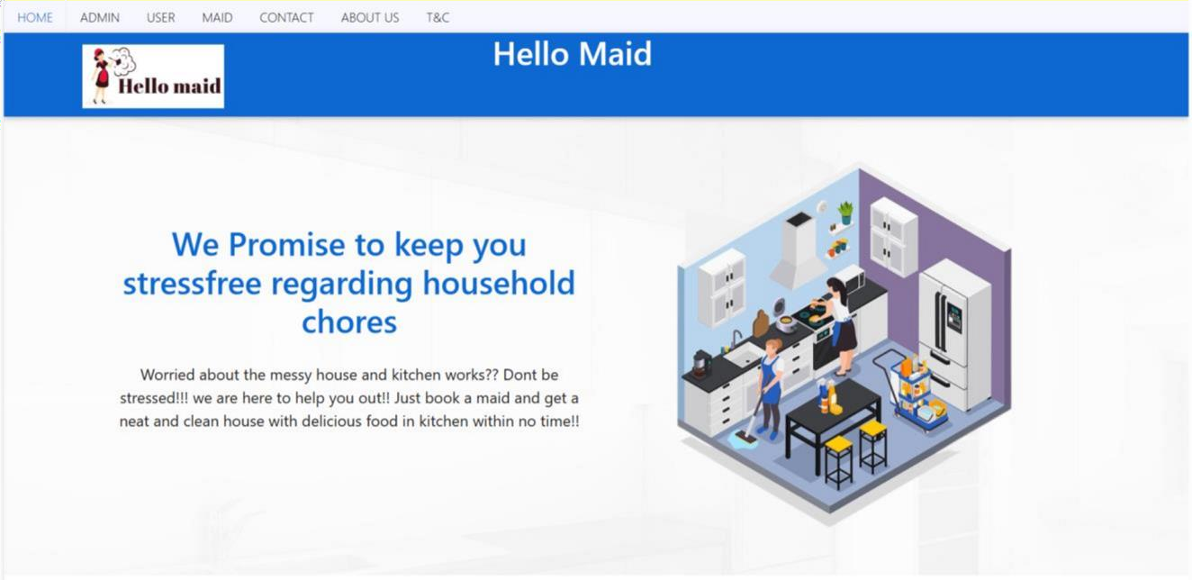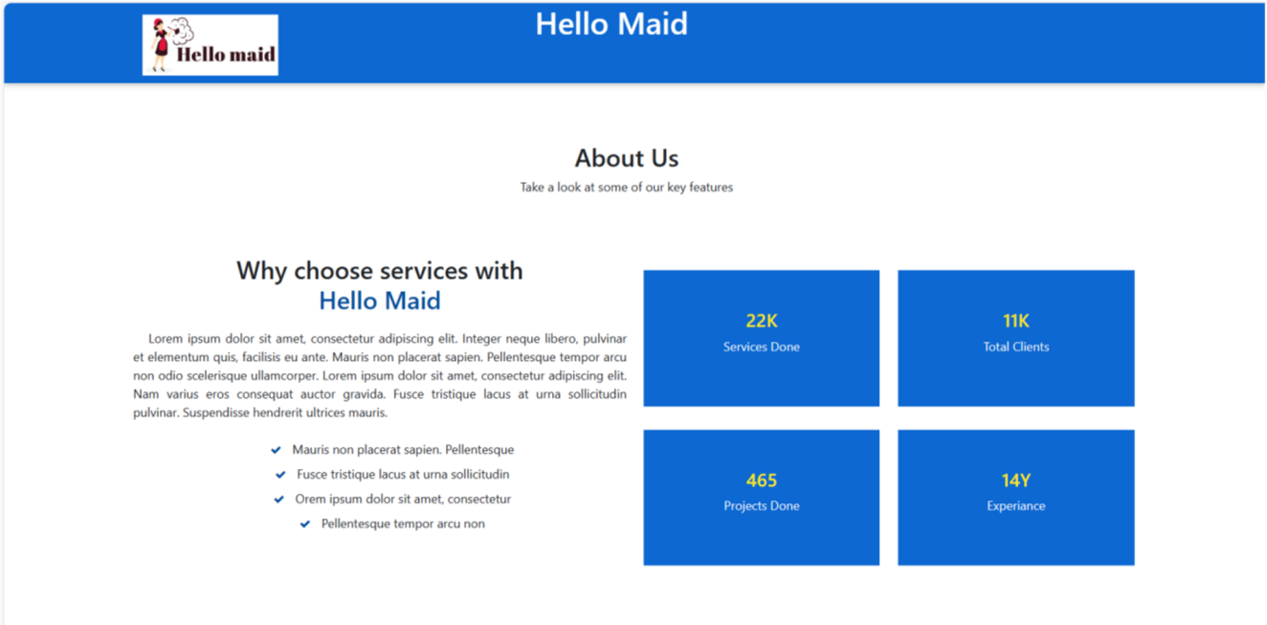

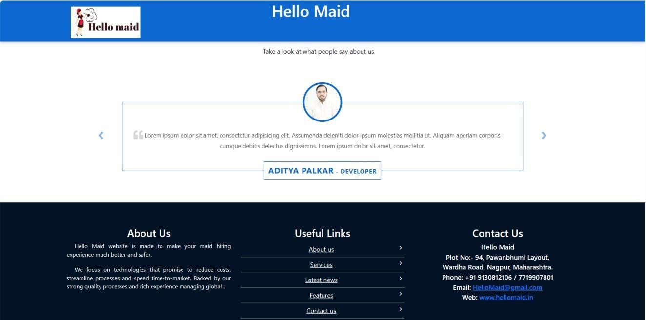

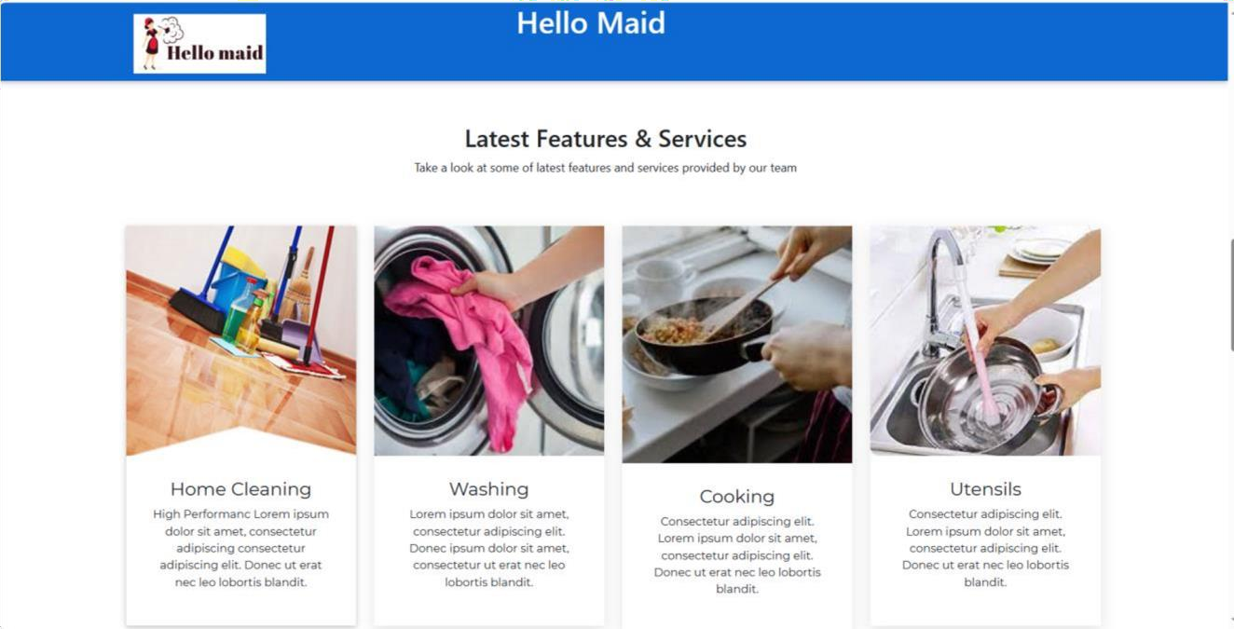

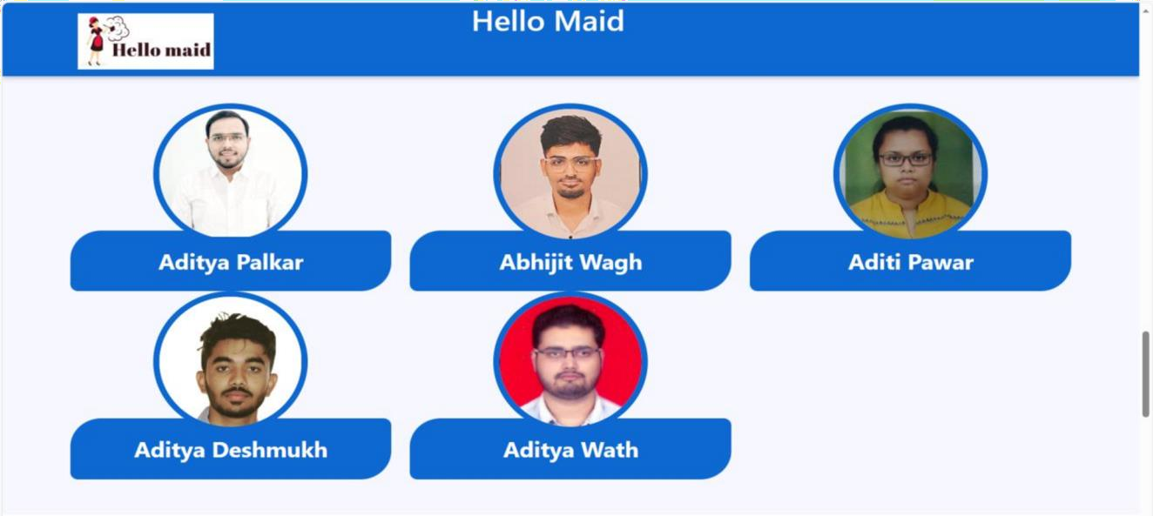

17

This page contains following controls

* + - Home
    - Admin
    - User
    - Maid
    - Contact
    - About Us
    - Terms And Conditions

18

* 1. **Contact And About Page**

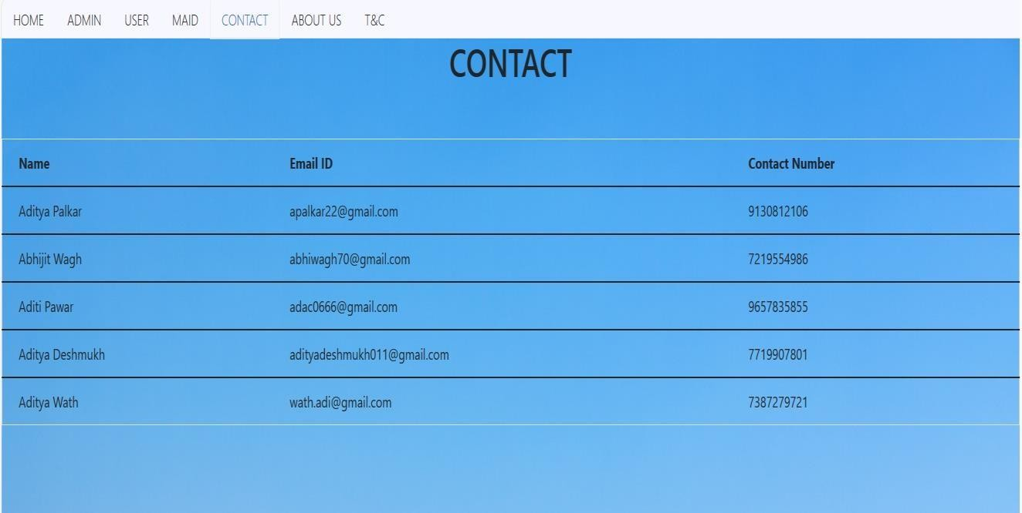

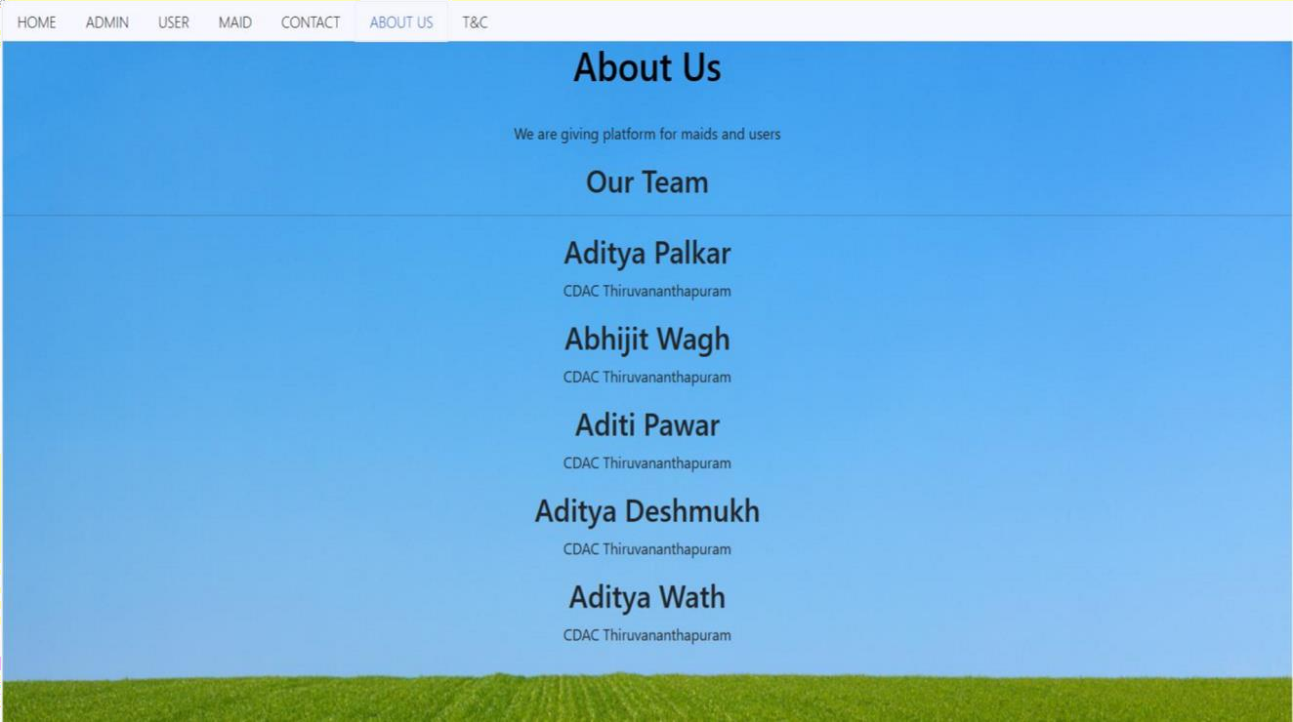

* 1. **Login Page**

Following snapshot shows the Login page for Admin

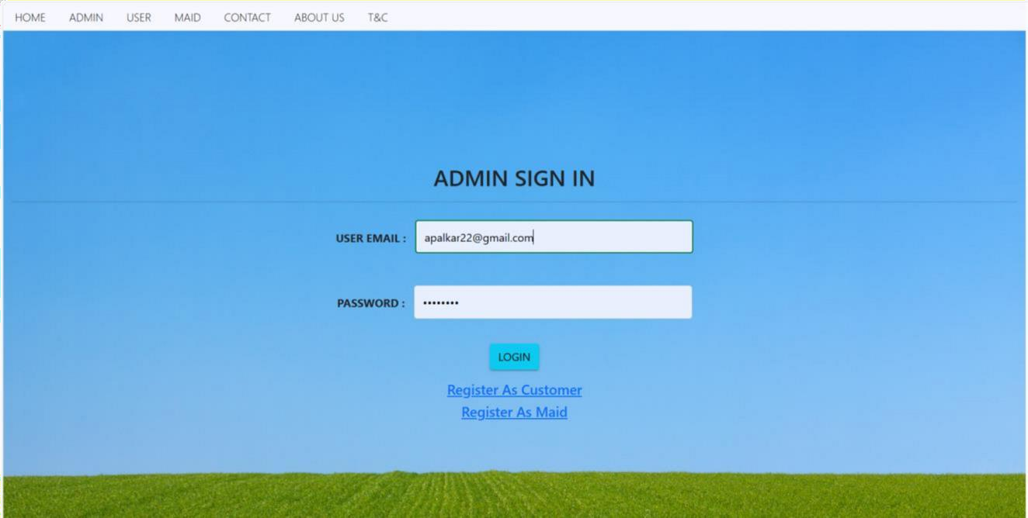

Following snapshot shows the Login page for User

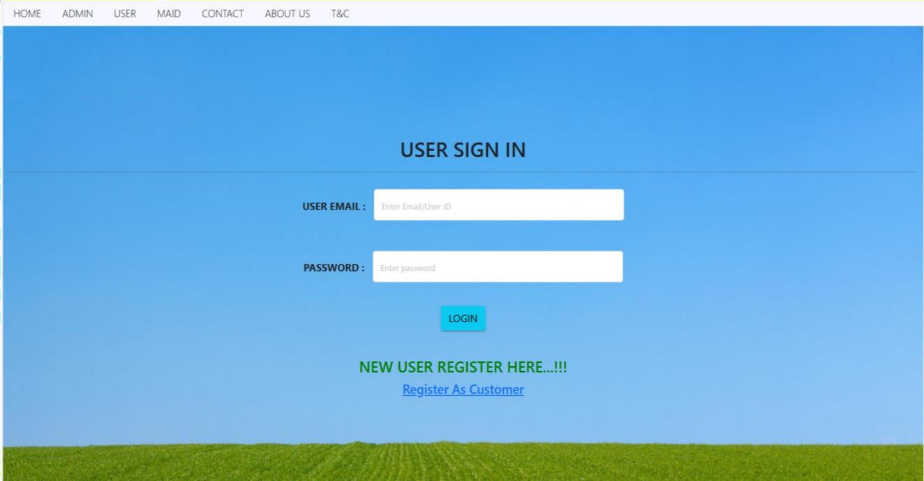

Following snapshot shows the Login page for Maid

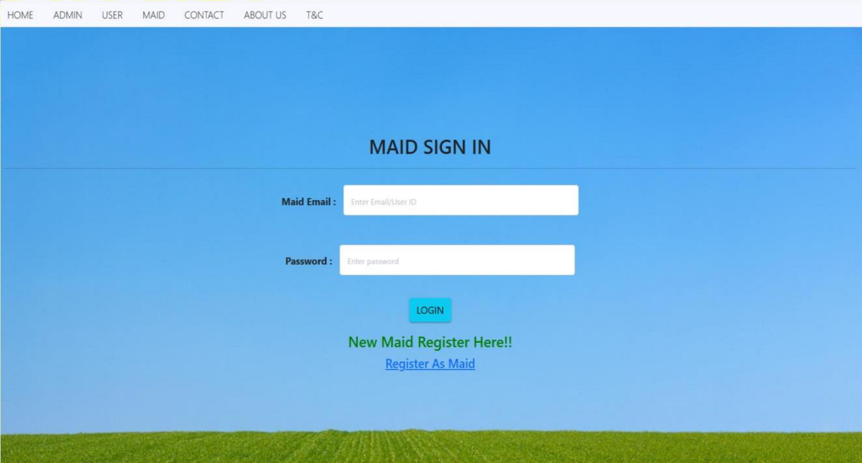

* 1. **Customer Registration Page**

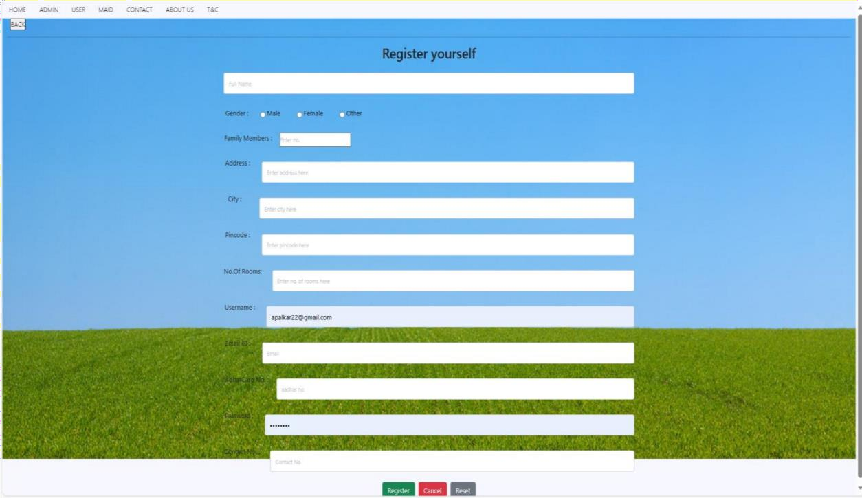

* 1. **Maid Registration Page**

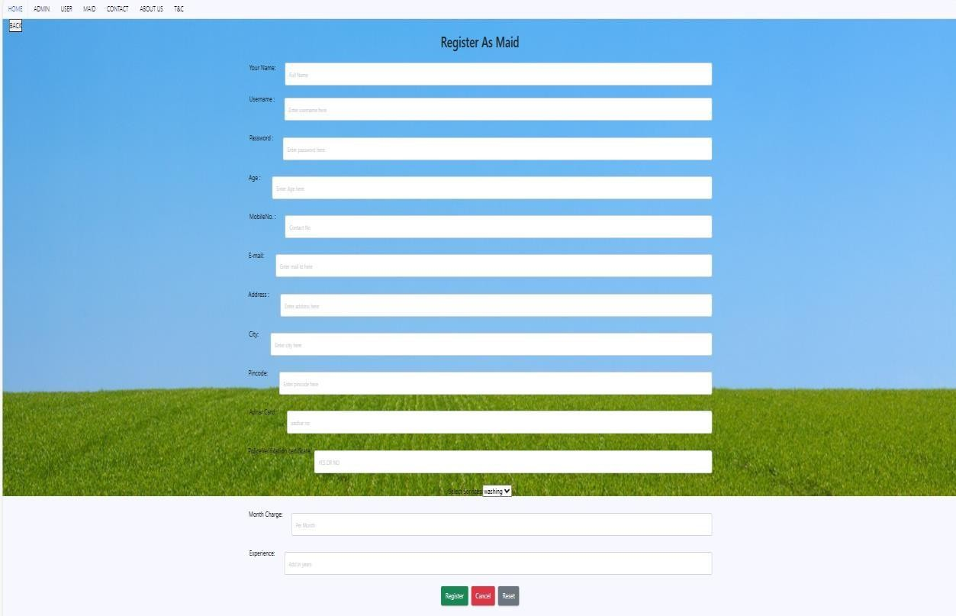

* 1. **Customer Booking Maid**
     1. **Customer Home page After Successful login**

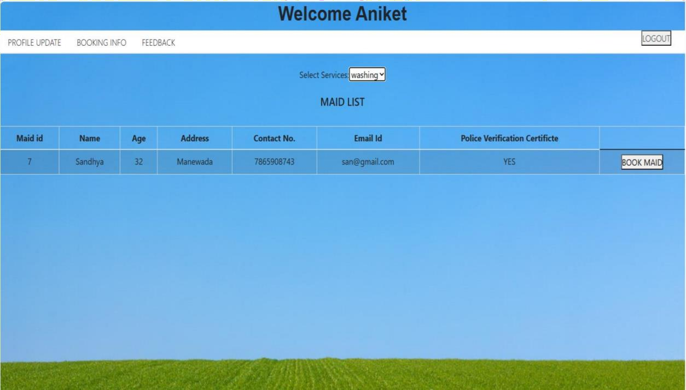

* + 1. **Customer Viewing Maid for Category Cleaning**

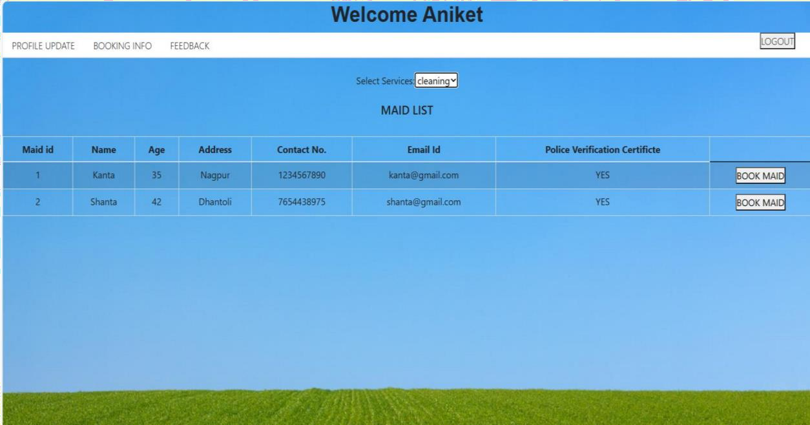

* + 1. **Customer Viewing Maid for Category Cooking**

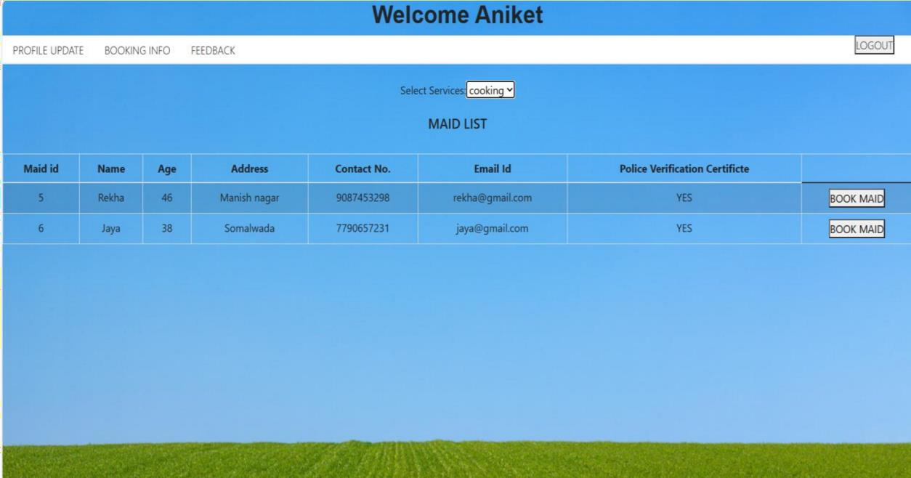

* + 1. **Booking Page**

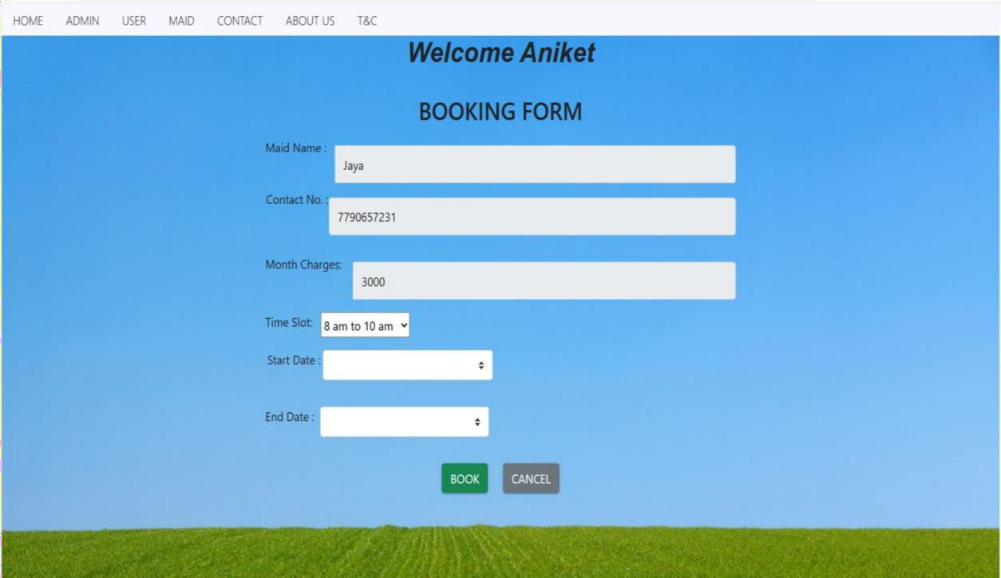

* + 1. **Booking Info (the bookings made by customer)**

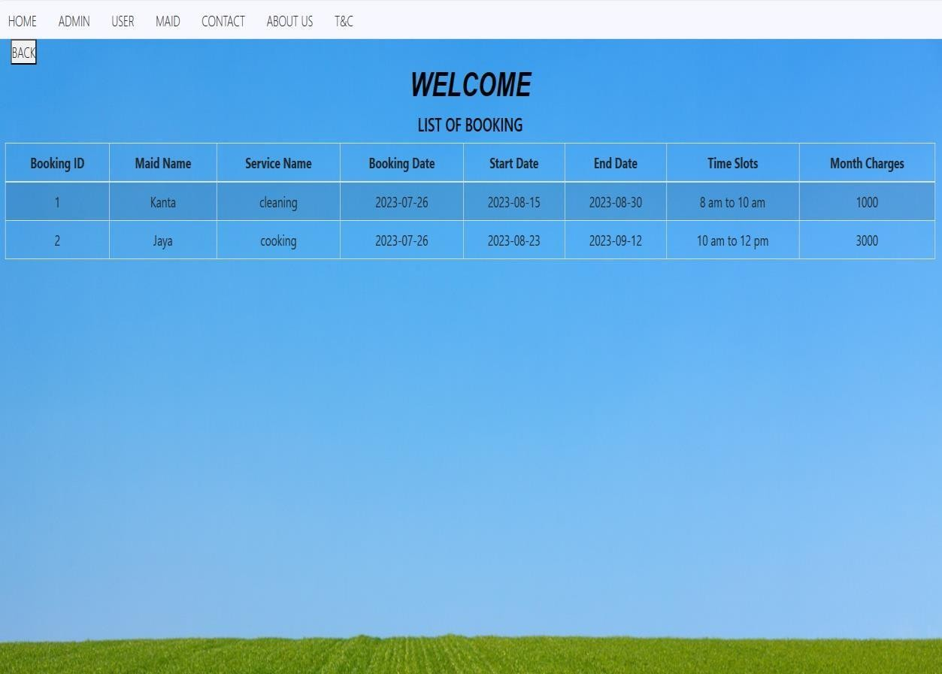

* + 1. **Customer Feedback Form**

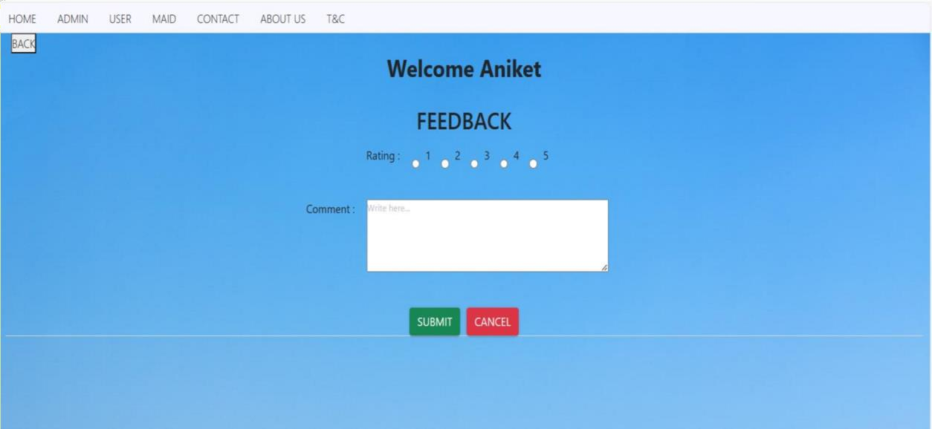

* + 1. **customer Personal Info(customer can update personal info )**

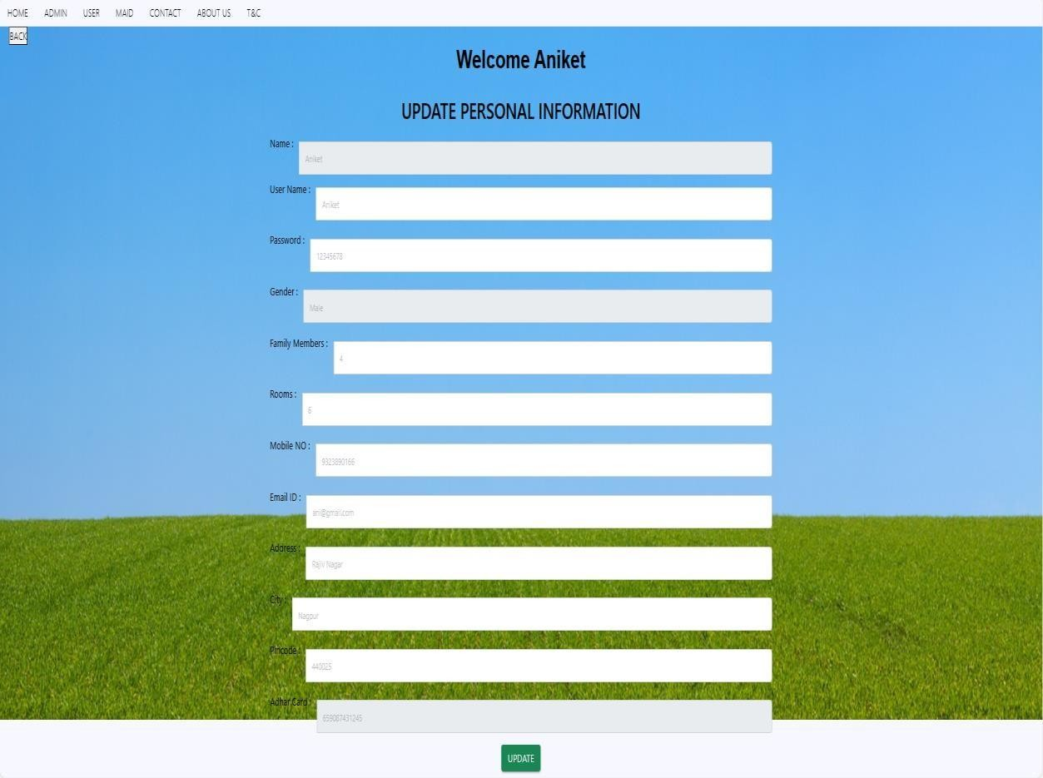

**7.7.7 Maid Update Profile Page updated by Admin**

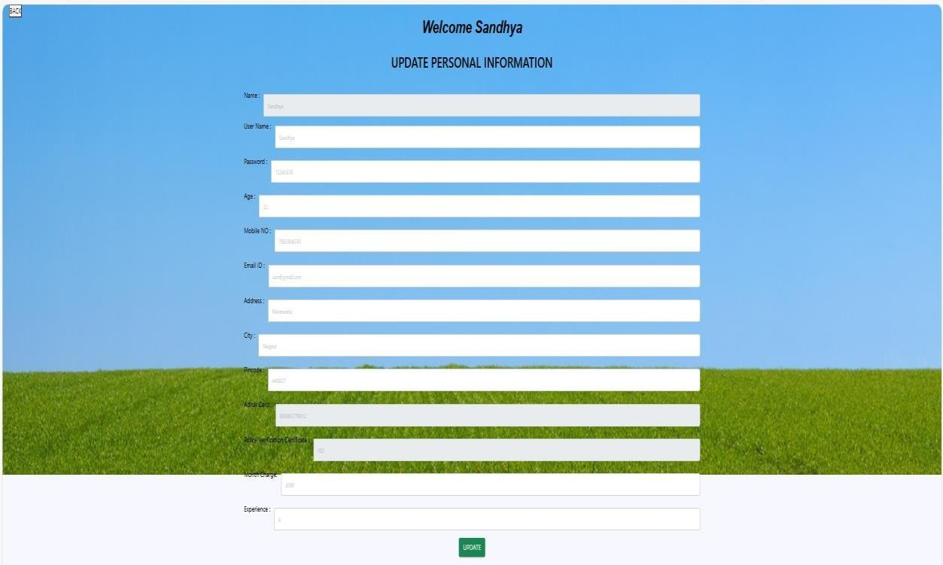

* 1. **Admin**
     1. **Admin Home Page**

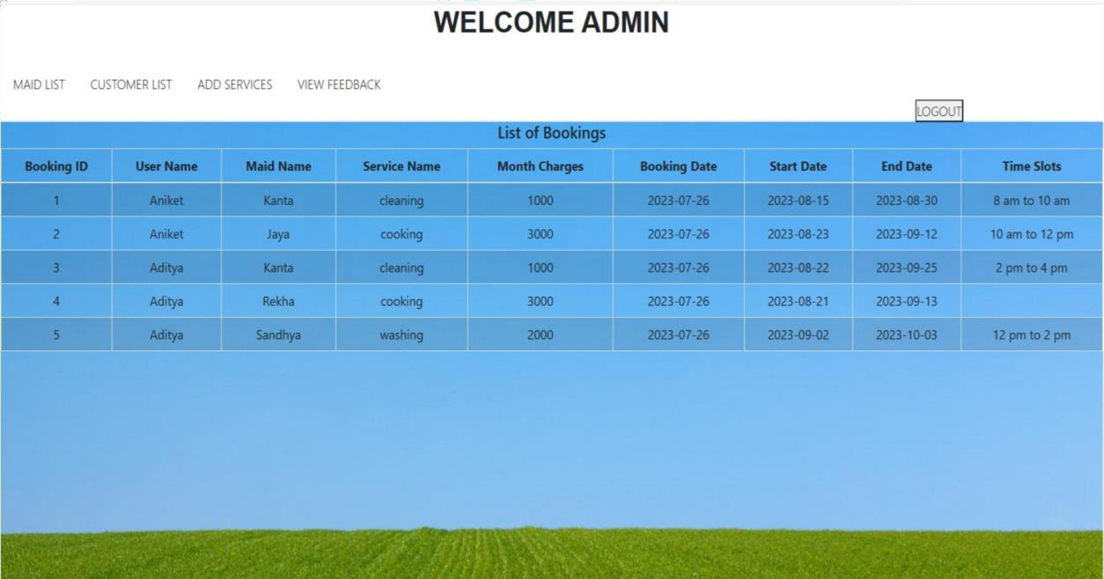

* + 1. **Maid Details for Admin**

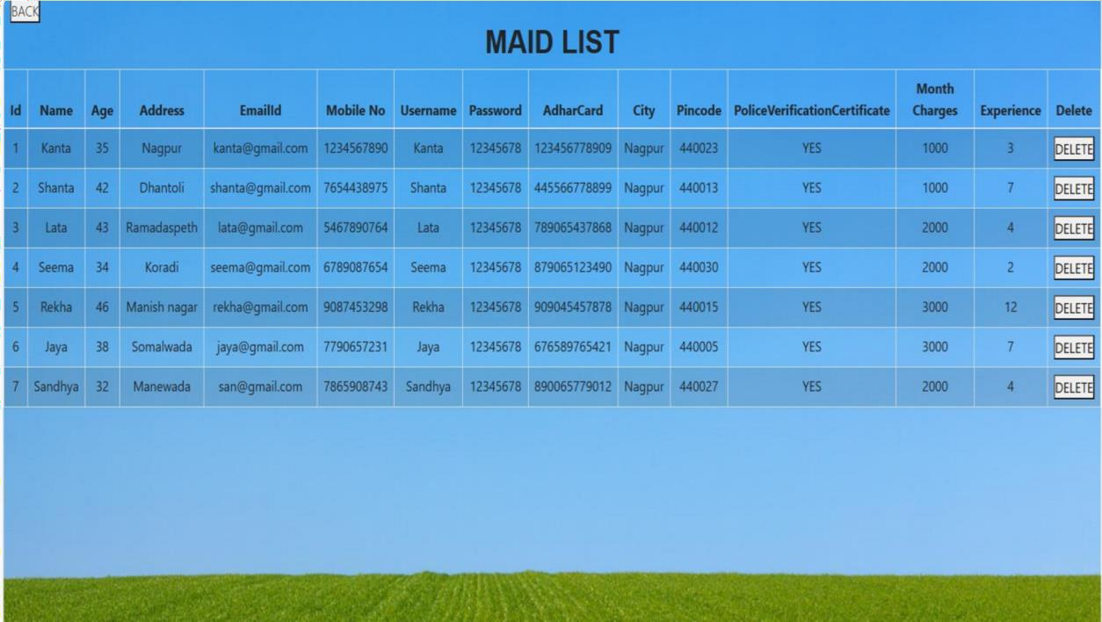

* + 1. **Customer Details Page**

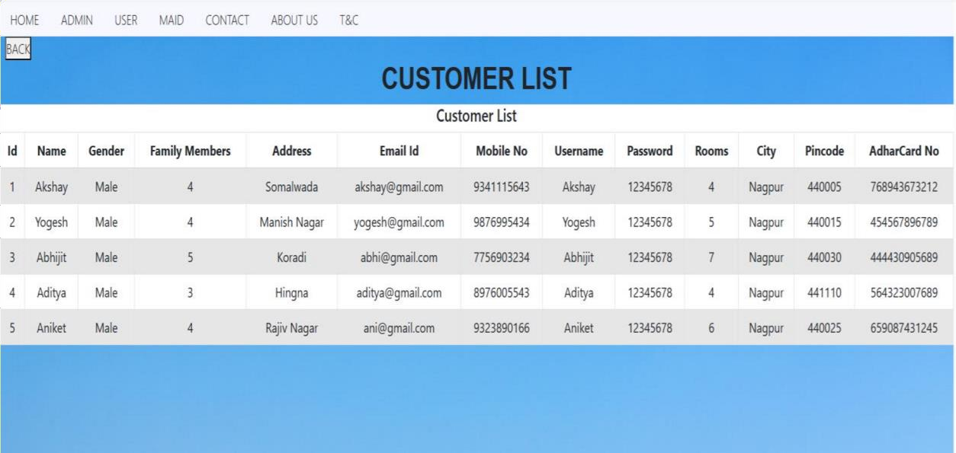

* + 1. **List of Feedback given by customer**

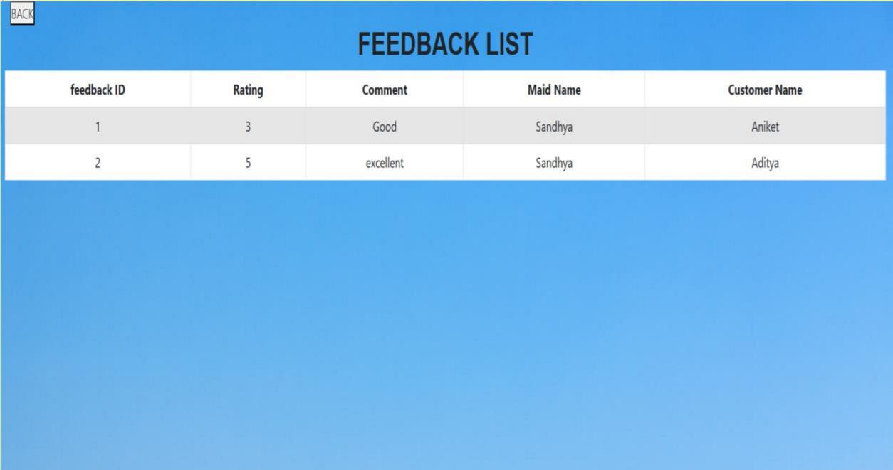

1. **Future Scope**

* Will add more categories in worklist of Maid.
* Will add another functionality of Maid Blacklisting.
* Admin can remove Blacklist maids from Application.
* Slots management should be done in proper way.
* Will add online payment functionality, e.g UPI’s

1. **Conclusion**

* Learnt the flow of how a project works.
* Initially have so much brainstorming about the project.
* Got to know how many processes are going on inside the project.
* Working with many technologies and making them work together.
* Got to know about various issues that can occur while development and how to resolve them.
* For several years we saw many websites but now we know how everything works.
* It was a great experience to work with different technologies and teammates.

1. **References**
2. Shahrzad Shahriari, Mohammadreza Shahriari, Saeid gheiji. “ ECommerce And It Impactson Global Trend And Market”.International Journal of Research – Granthaalayah. Vol.3 (Iss.4): April, 2015.
3. L.RichardYe, Yue Jeff Zhang, Dat-DaoNguyen, James Chiu,“Fee-based online services: Exploring consumers’willingness to pay ”. Journal of International Technologyand Information Management
4. JavaScript Enlightenment, Cody Lindley-First Edition, based on JavaScript 1.5, ECMA-262,

Edition

1. Mc Graw Hill’s, Java: The complete reference 7thEdition, Herbert Scheldt
2. Complete CSS Guide, Maxine Sherrin and John Allsopp-O'ReillyMedia; September 2012